Hello everyone, in today's session we are going to talk about PYQT tutorials. So we will be talking about PYQT training and this level of the training would be beginners level. So let's begin with PYQT training. Difficulty level, so the course level will be a difficulty level will be beginners and in order to start with this course, you must have the following skill sets. So to start with this course, the skill sets includes are knowledge of Python, so you should have the basic knowledge of Python. What is Python and what are different data types, collections etc. in Python. Knowledge of PyCharm, since we are going to write the code in PyCharm IDE, so if you are not comfortable with PyCharm IDE, you can also write in Python console, but then you need to install the PYQT first before starting with Python console.
Course objectives, so from this course participants will be able to understand what is PYQT, so we will be understanding what is PYQT and installation of PYQT, creating application using PYQT, so we will be creating different applications by using PYQT, understanding GUI applications, what is GUI and what are different types of GUI applications and what is PYQT GUI for us. Get knowledge of different widgets in PYQT, so we will be getting knowledge of different widgets which is available in PYQT, so what widgets are available in PYQT. What will you learn in this course? So participants will be able to learn about introduction to PYQT, introduction to QTGUI, creating a frame using QApplication, different widgets of QTGUI, menus in PYQT, dialogues in PYQT, toolbars in PYQT, events and signal in PYQT, that's it. Are there any course requirements or prerequisites? Yes, in order to start with this course, we have certain course requirements and prerequisite. This requirements includes knowledge of basics of Python, basics of PyCharm and softwares which should be installed are PyCharm, any of the application whether you are using any operating system, that's it.
Then we should also have PYQT plugin, so I will be showing you how to install PYQT in PyCharm or if you are not a PyCharm user, if you want to do it on a console, how we can install it in console. Who are the target students? So any student or any participant working in an IT sector, participant who wish to learn about GUI application, so if you want, if you wish to learn about what is GUI and how to create a GUI applications, participant working as a GUI developer, if you are working in any other segment of GUI developer, suppose if you are a Java GUI developer or PySite GUI developer, you want to switch to PYQT, then again you can offer this course and anyone who wish to learn and be a GUI developer using PYQT, so if you wish to learn about PYQT and you want to become a GUI developer using PYQT, this course you can learn. By the end of this course, you will have the following skill set, so by the end of this whole course, the whole session with tutorials, you would be able to create GUI applications in PYQT, you will be learning our different widgets available in PYQT, Qt GUI applications and Q applications in PYQT. So in this course, what are we going to learn or what is the course contents for PYQT beginners? So this course contents includes introduction to PYQT, so now we will be starting with introduction to PYQT. In the next session, we are going to learn about introduction to Qt GUI, we will be checking how to create a frame using Q applications, different widgets in Qt GUI, menus in PYQT, dialogues in PYQT, toolbars in PYQT and event and signals in PYQT.
So in the beginners level of PYQT, we are going to learn all these following topics. So let's get started now. Now in order to start with the first thing, let's start with introduction to PYQT and what is a PYQT for us. So what is the basic thing which comes in our mind when we talk about PYQT programming? So if I ask you a simple question, what is PYQT? What's the basic answer we'll get? So if you check this PYQT, it is a combination, basically it's a combination of two different words.
PY is a one word and Qt is another word. So basically PYQT is combination of two words. This is includes as PY which stands for Python and Qt which is here exactly libraries, Qt libraries. So in this PYQT, what are we going to learn is, see now if we know that it is a combination of two words which is called as Python and Qt libraries. So we are creating an Qt application using Python programming. So basically in this PYQT, what are we going to do is, we are going to learn about Qt application development by writing Python codes. That's the simple thing which we are going to learn.
Now what is PYQT? So like when we talk about PYQT, it's just a GUI tool, it's a GUI tool for us. Also when we talk more about PYQT, it's powerful cross-platform GUI. That means whenever we are developing any application by using PYQT, we are creating a cross-platform application. So when we talk about cross-platform application, that means it will be support on different platforms. So PYQT consists of Qt core libraries and Qt GUI libraries. This is the common libraries which you will be getting plus additional libraries which you will be availing like Qt SQL, Qt XML etc. which we are going to see in the advanced and intermediate level of PYQT.
But for right now, since we are only talking about GUI application, so we are going to check only Qt core and Qt GUI. But lot of things which PYQT consists of. So again to give a quick revision what it is exactly. So PYQT is combination of two words, that means this PYQT is defining two different statements. PY is called as a Python programming and Qt stands for Qt libraries, that's your GUI libraries. So whenever we create a GUI application or whenever we are creating any Qt applications by using Python programming, that is called as PYQT. PYQT is basically a GUI tool.
So now when we are talking lot of about GUI, so we know that it's a GUI tool given to us. It is also cross platform, that means it can be support on multiple platforms. If you are writing the code once, you can execute it on multiple platforms. Also PYQT supports of many libraries. So core libraries which we are taking as Qt core, which we are learning as Qt GUI in this particular session. But in the next session we are also going to learn different more libraries about PYQT.

Albatta, mana sizning matningizni strukturalangan ko'rinishda tarjima qildim:

PYQT Darsiga Kirish (Introduction to PYQT)
Kursni boshlash darajasi:
- Kurs darajasi: Boshlang'ich daraja (Beginner level)
- Kursni boshlash uchun zarur ko'nikmalar:
  - Python bo'yicha bilim (Knowledge of Python): Pythonning asosiy tushunchalari (basic knowledge of Python), ma'lumot turlari (data types), kolleksiyalar (collections) va boshqalar.
  - PyCharm bo'yicha bilim (Knowledge of PyCharm): Kodni PyCharm IDEda yozish. Agar PyCharm bilan tanishmasangiz, Python konsolida (Python console) ham yozishingiz mumkin, ammo PYQTni avval o'rnatish kerak bo'ladi.

Kurs Maqsadlari (Course Objectives)
- Ishtirokchilar PYQT nima ekanligini tushunib olishadi.
- PYQTni o'rnatish (Installation of PYQT).
- PYQT yordamida ilovalar yaratish (Creating applications using PYQT).
- GUI ilovalari (GUI applications) haqida tushuncha olish, GUI nima ekanligini va turli GUI ilovalarini tushunish.
- PYQT GUI haqida bilimga ega bo'lish.
- PYQTda mavjud bo'lgan turli vidjetlar (widgets) bilan tanishish.

Kursda Nima O'rganiladi (What Will You Learn in This Course)?
Ishtirokchilar quyidagi mavzularni o'rganishadi:
- PYQT-ga kirish (Introduction to PYQT)
- QTGUI-ga kirish (Introduction to QTGUI)
- QApplication yordamida ramka yaratish (Creating a frame using QApplication)
- QTGUI-dagi turli vidjetlar (Different widgets of QTGUI)
- PYQT-da menyular (Menus in PYQT)
- PYQT-da dialoglar (Dialogues in PYQT)
- PYQT-da asboblar paneli (Toolbars in PYQT)
- PYQT-da hodisalar va signallar (Events and signals in PYQT)

Kurs Talablari va Oldindan Talablar (Course Requirements and Prerequisites)
- Kursni boshlash uchun talablar:
  - Python asoslari (Basics of Python).
  - PyCharm asoslari (Basics of PyCharm).
  - PyCharm IDE yoki Python consoleda ishlash uchun PyQT plaginini o'rnatish kerak.

Kimlar Uchun Mo'ljallangan (Target Students)
- IT sohasida ishlayotgan talaba yoki ishtirokchilar (Students or participants working in the IT sector).
- GUI ilovalarini o'rganishni xohlaganlar (Those who want to learn about GUI applications).
- GUI dasturchilari (GUI developers), agar siz Java GUI yoki PySite GUI dasturchisi bo'lsangiz va PYQT ga o'tishni istasangiz.
- PYQT yordamida GUI dasturchisi bo'lishni xohlaganlar.

Kurs Oxirida Ko'nikmalar (Skills You Will Gain by the End of the Course)
- PYQT yordamida GUI ilovalarini yaratishni bilasiz.
- PYQTda mavjud bo'lgan turli vidjetlar (widgets).
- Qt GUI ilovalari (Qt GUI applications) va Q ilovalar (Q applications in PYQT) bilan ishlashni bilib olasiz.

Kurs Mazmuni (Course Contents)
- PYQT-ga kirish (Introduction to PYQT)
- Qt GUI-ga kirish (Introduction to Qt GUI)
- QApplication yordamida ramka yaratish (Creating a frame using QApplication)
- Qt GUI vidjetlari (Qt GUI widgets)
- PYQT-da menyular (Menus in PYQT)
- PYQT-da dialoglar (Dialogues in PYQT)
- PYQT-da asboblar paneli (Toolbars in PYQT)
- PYQT-da hodisalar va signallar (Events and signals in PYQT)

PYQT Nima? (What is PYQT?)
- PYQT - bu GUI vositasi (GUI tool).
- PYQT - ko'p platformali GUI (cross-platform GUI), ya'ni bir marta kod yozib, uni turli platformalarda ishlatish mumkin.
- PYQT - Qt yadro kutubxonalari (Qt core libraries) va **Qt GUI kutubxonalari (Qt GUI libraries)**dan iborat.

PYQT va QTGUI:
- PYQT - Python dasturlash tilidan foydalanib Qt ilovalarini yaratish.
- PYQT yordamida yaratilgan dasturlar ko'p platformali (cross-platform) bo'lib, ular turli operatsion tizimlarda ishlaydi.
- Qt GUI - grafik foydalanuvchi interfeysi (GUI) yaratish uchun zarur kutubxonalar to'plami bo'lib, ularni PYQT yordamida ishlatamiz.

PYQT O'rnatish (Installation of PYQT)
- PyCharmda loyiha yaratish (Create a project in PyCharm):
  - PyCharmni oching va yangi loyiha yaratish uchun fayl (file) -> yangi loyiha (new project)ni tanlang.
  - Pure Python projectni tanlang, loyiha nomini kiriting va interpreterni tanlang.
- PyQT o'rnatish:
  - PyCharmda Project Interpreterga o'ting.
  - PyQT5 paketini o'rnatish uchun Add tugmasini bosing va Install tugmasini bosing.
- PyQT, PyQT5 Stubs va PyQT5 Sipni o'rnatish:
  - PyQT5 Stubs va PyQT5 Sip paketlarini o'rnatish kerak.
  - Buning uchun pip install pyqt5 komandasini ishlatish mumkin.
- Konsolda o'rnatish:
  - Agar IDE ishlatmaysiz bo'lsa, Python consoleda ham o'rnatish uchun pip install pyqt5 deb yozishingiz mumkin.

Xulosa (Conclusion)
- PyQT o'rnatilishi juda oson, faqat PyCharmda yoki Python console orqali kerakli paketlarni o'rnatish kerak.
- PyQT5 - hozirgi vaqtda pyqt dasturlash uchun eng so'nggi versiyadir.

Now, in this session, we are going to talk about introduction to QTGUI. So, basically when we talk about QTGUI, the first thing which comes in our mind is what is QTGUI. So, as it is QT is a QT libraries, it's also a combination of two words, so QT is your QT libraries and GUI is standing for Graphical User Interface or you can say Graphic User Interface. So, basically when we talk about a Graphic User Interface, the first thing which comes in our mind is a graphical application or a web application which contains graphics. So, QTGUI is a combination of QT libraries plus Graphical User Interface. So, here the comment statement says that it is QTGUI. So, QTGUI deals with graphical elements, so QTGUI deals with graphical elements, also you can say all GUI widgets, it simply terms as any widget like a Q application, like your button or anything which is acting as a widget for you, for an graphic to interface with the user.
So, when we talk about Graphical User Interface, the first thing what we have to understand, suppose this is an application right now, so this is my application, so when I click on this, I get a pop-up screen, menu bar. So, menu bar is interacting by a user to me. So, suppose I am a user and I am able to interact this particular menu bars, if I click on any of the option, like for example, if I click on format, I click on font option, I am able to see a pop-up, that's a dialog. So, dialog is again for me will be a GUI, then whatever I am writing behind is a text area, so this text area also becomes an GUI, this buttons also become a GUI, dropbox, navigation, etc. So, these are all widgets, this widgets will be also available with your Qt GUI, so it also deals with to it. So, Qt GUI also includes your tables, tree, list etc. and also Qt GUI follows MVC design pattern. So, you know about MVC concept, that's called as model view controller, so Qt GUI follows MVC design pattern also and also benefit for 2D graphics or 2D canvas.
So, these are the basic things which will be working with Qt GUI. So, when we talk about Qt core, that is again a core element, which does not have any GUI structures written to it and whereas when we are dealing with Qt GUI, it is completely dealing with the graphical user interface. Now, what we are going to see is how to install a pyqt. So, as I said we will be using PyCharm, but if you are comfortable with any other language, you can definitely go for it. So, this is my PyCharm, I have just created a simple project, what you can do is you can just click on file, new project. You can select pure python project and just give a project name, for example, let's say if I give a project name as first project interpreter, so you can select your basic virtual interpreter and just click on the create button. So, once you click on the create button, your project will be created.
So, I have created a project which is named as first right now, correct. Now, what are we going to do in this project is, the first thing we have to install pyqt. So, how will we be installing pyqt in this project? So, what we have to do is, we just have to go to file, in this file you have to go to settings. So, when you go to settings, you will get the project settings. So, this is appearance and behavior, where you can select appearance, key map, editors, plugins. So, you just go to project option from there.
In this project option, you have two things, project interpreter and project structures. Out of which, you have to select project interpreter. Now, when you select this project interpreter, you see your python core is already working, your python exe which has pip package and setup tools. Now, in order to work with pyqt, what you have to do is, you just need to click on this add button and in this, you will be getting different packages through which I will be selecting pyqt5. So, I want to take a pyqt5 files and just click on the install package. So, you can see, it's getting downloaded over here. Okay, I will just show you.
So, you can see over here, it is downloading and once it is installed, you will get a message over here that pyqt5 is completely installed with your system. You can again specify the versions, suppose if I am using pyqt5, so I am using 5.15. If you want to use a lesser version of it, you can also use. But yes, pyqt5, that's the version 5, is the latest version right now for pyqt programming. So, we are going to learn with the latest versions only. Yes, apart from it, what else you have to install for pyqt? So, this is the basic package which will be there.
Also, you need to install this stubs. So, basically, it's all the stuff files for pyqt. So, it will be also having a lot of files. So, you need to install this as well. And pyqt sip, that module is a sip module for pyqt. Just click on this install package. So, these three packages which we need to install in your system.
Now, you can see, it's showing you pyqt5 stubs installed successfully. So, this is installed, sip is installed and pyqt is now also installed. When I click on close, you can see pyqt stubs and pyqt sip. All three are installed. You just click on OK. And here, that's it. It's quite simple to do when you are doing with a, because if you are not working with, and if you have anything, Python console or something like that.
So, how at that time I can handle this thing? So, what you have to do is, you just need to write a command. And what is the command which you have to write? So, you just have to say pip. That's for installing anything as a Python programming. What you can just do is, you can just write. I'll just give you a simple thing to show you.
Let's say, I will use a Python console. I will open a Python console. And in this Python console, you can just type a console command. It is pip. So, whenever you are installing a pip, you will be getting a pip installation. But you have seen, we do not have any pips right now. You have to also install a pip.
So, what you just do is, you just need to type pip install pyqt5. Just particularly enter this command. And then, you are able to install your pyqt in the system. That's it. It's quite simple. If you are doing with the IDEs, you can just install it from here. If you are not using any IDE, you can just say pip install pyqt5. pip install pyqt5 slash ship.
And pip install pyqt5 slash stubs. These three libraries are must to work with it. Okay.

QTGUI-ga kirish:
Endi, ushbu sessiyada biz QTGUI (Qt Graphical User Interface) ga kirish haqida gaplashamiz. Shunday qilib, QTGUI haqida gapirganda, birinchi navbatda bizning ongimizga keladigan savol – QTGUI nima?
QTGUI nima?
QT – bu Qt kutubxonalari (Qt libraries), bu ikki so'zning birlashmasi (combination) bo'lib, GUI esa Graphical User Interface (grafik foydalanuvchi interfeysi) yoki Graphic User Interface (grafik foydalanuvchi interfeysi) degan ma'noni anglatadi. Demak, QTGUI – bu Qt kutubxonalari va grafik foydalanuvchi interfeysining (Graphical User Interface) birlashmasi.
Grafik foydalanuvchi interfeysi (GUI) haqida umumiy tushuncha:
- Grafik foydalanuvchi interfeysi (GUI) haqida gapirganda, bizning ongimizga birinchi keladigan narsa grafik ilova yoki veb ilova bo'lib, ular grafikalar (graphics)ni o'z ichiga oladi.
- QTGUI grafik elementlari (graphical elements) bilan ishlaydi. GUI vidjetlari (widgets) har qanday interaktiv elementni anglatadi, masalan:
  - QApplication (Q ilova)
  - Tugmalar (buttons), dropdown ro'yxatlar (dropdown lists) va boshqa turli interaktiv elementlar.
Grafik foydalanuvchi interfeysi (GUI) va uning ishlashi:
- Masalan, hozirda bu ilova (application), bu mening ilovam, va agar men buni bosganimda, pop-up (yangi oynali) ekrani, menyu paneli (menu bar) chiqadi.
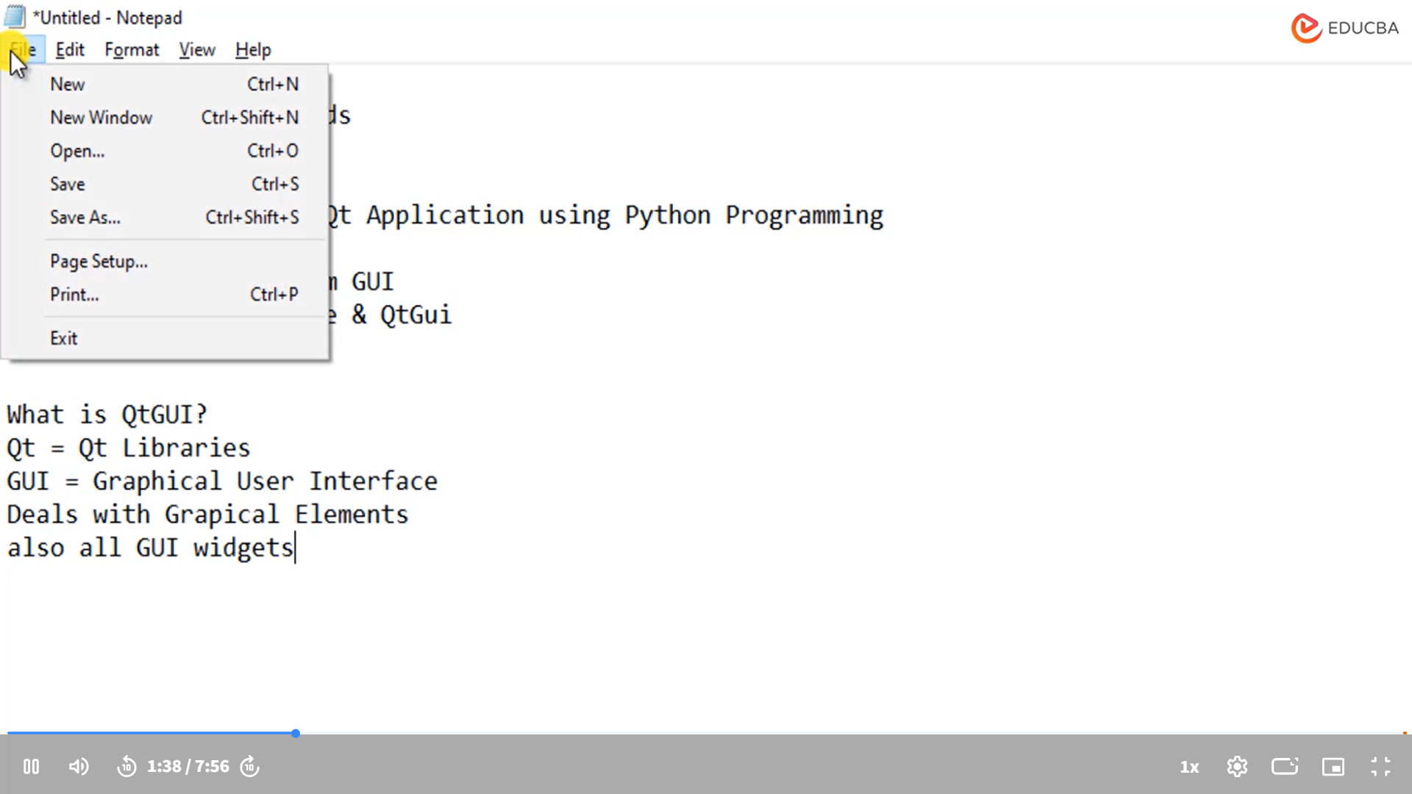
- Menyu paneli foydalanuvchi tomonidan ishlatiladigan GUI elementidir. Menyu paneli bilan o'zaro aloqada bo'lish mumkin, masalan, formatni tanlab, fontni o'zgartirish.
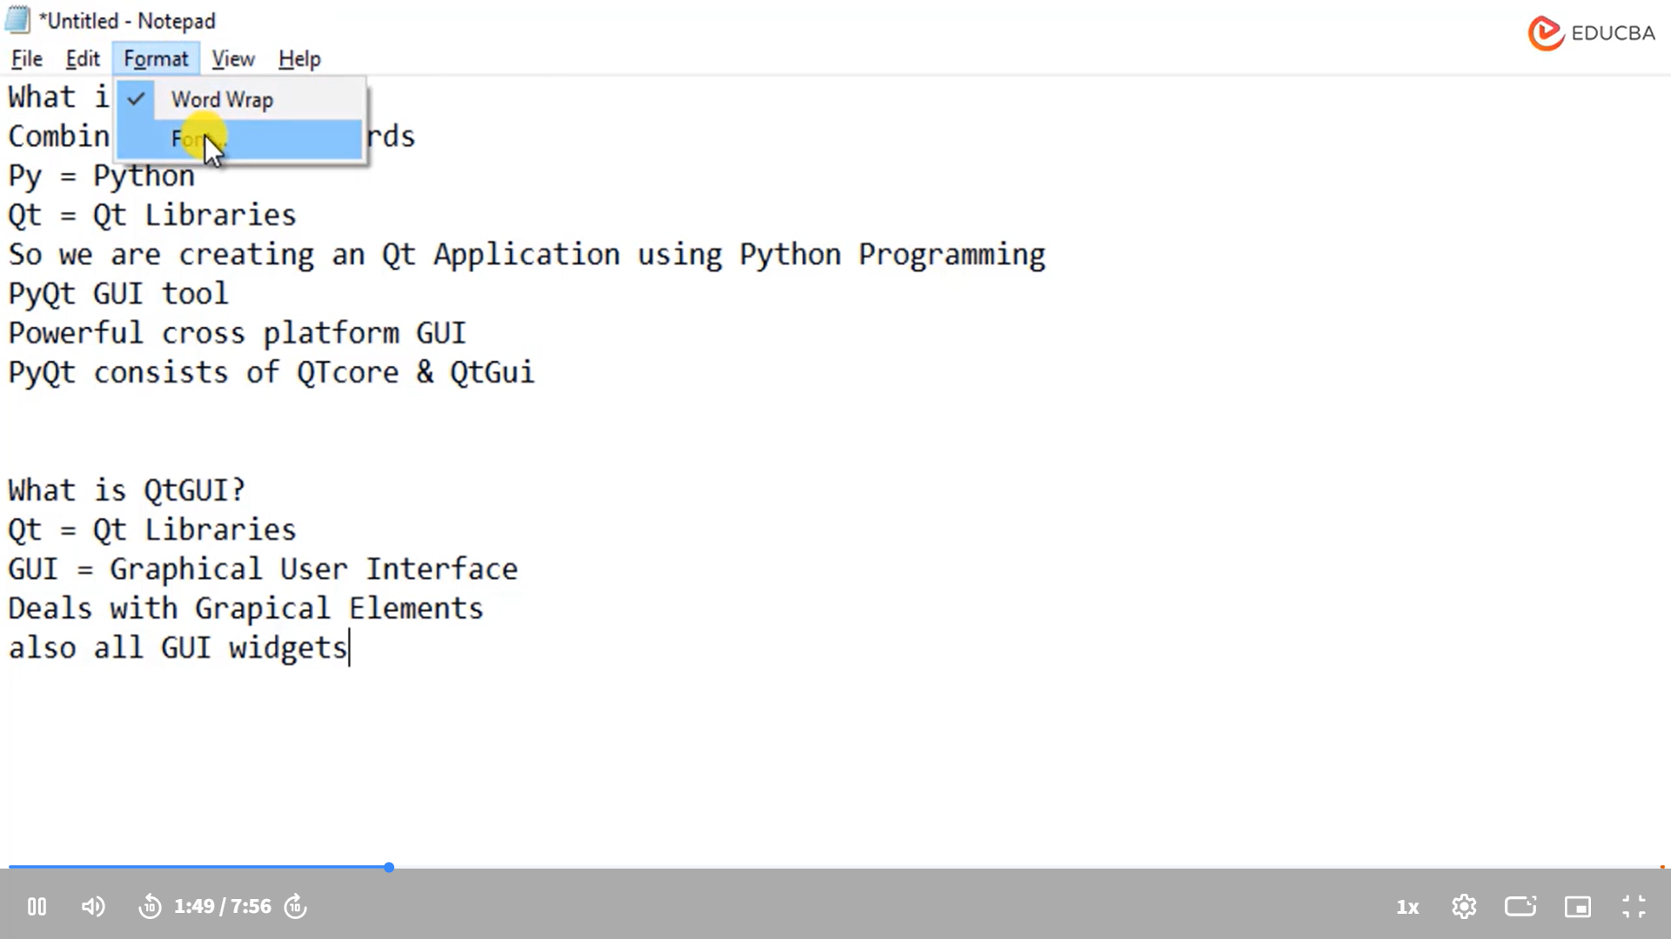
- Dialog – bu yana bir GUI elementidir, bu sizga yangi ekranda tanlov qilish imkonini beradi.
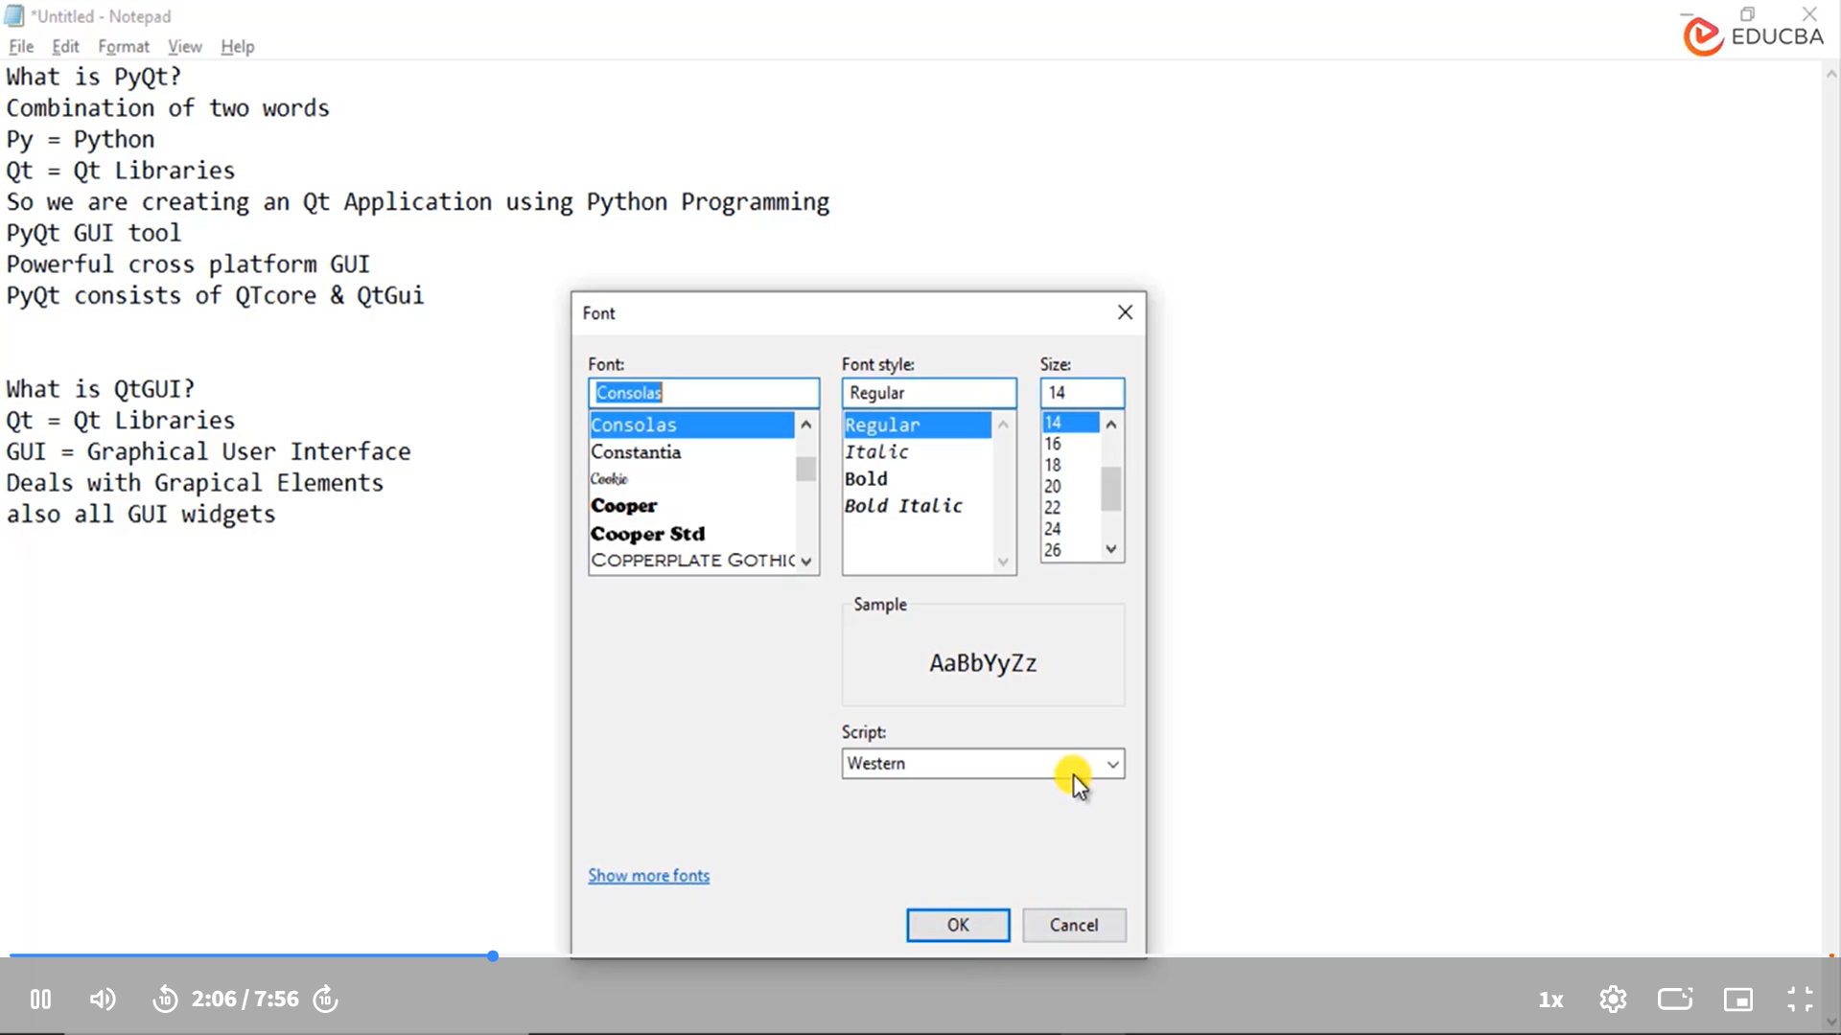
- Matn maydoni (text area), tugmalar (buttons), dropdown ro'yxatlar (dropdown lists) – bularning barchasi GUI vidjetlari sifatida ishlaydi.
QTGUI imkoniyatlari:
- Qt GUI jadvallar (tables), daraxtlar (trees), ro'yxatlar (lists) kabi ko'plab interaktiv elementlarni qo'llab-quvvatlaydi.
- MVC dizayn shabloni (Model View Controller design pattern) – Qt GUI MVC dizayn shablonini (design pattern) amal qiladi.
- 2D grafikasi (2D graphics) yoki 2D kanvas (2D canvas) – Qt GUI 2D grafikalar bilan ishlashni qo'llab-quvvatlaydi.
Qt core vs Qt GUI:
- Qt core - bu asosiy (core) kutubxona bo'lib, u faqat umumiy funksiyalarni o'z ichiga oladi, lekin unda grafik foydalanuvchi interfeysi (GUI structures) yo'q.
- Qt GUI - bu to'liq grafik foydalanuvchi interfeysi (GUI) bilan ishlaydi va turli interaktiv elementlarni qo'llab-quvvatlaydi.

PyQT-ni o'rnatish (Installing PyQT):
Endi, PyQTni qanday o'rnatishni (install) ko'rib chiqamiz. Men PyCharm IDE (Integrated Development Environment)ni ishlatishni taklif qilaman, ammo boshqa tilda (language) ishlashda qulay bo'lsangiz, albatta, boshqa muharrirlarni (editors) ham ishlatishingiz mumkin.
- PyCharm’da loyiha yaratish (Create a project in PyCharm):
  - PyCharmni oching.
  - Fayl (file) -> Yangi loyiha (new project) ni tanlang.
  - Pure Python project ni tanlang va loyiha nomini (project name) kiriting, masalan "first project".
  - Interpreterni tanlang va "Create" tugmasini bosing.
- PyQT o'rnatish (Install PyQT):
  - Loyiha sozlamalariga (project settings) kirish uchun File -> Settings ga o'ting.
  - Project Interpreter ni tanlang.
  - Add tugmasini bosing va pyqt5 ni tanlab, o'rnatish tugmasini (install) bosing.
  - PyQT5 o'rnatilgach, sizga muvaffaqiyatli o'rnatilgani haqida xabar (message) beriladi.
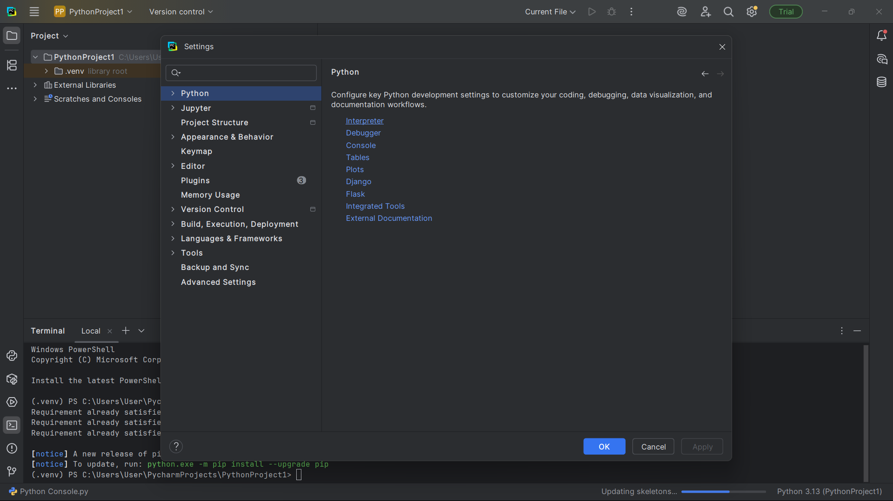
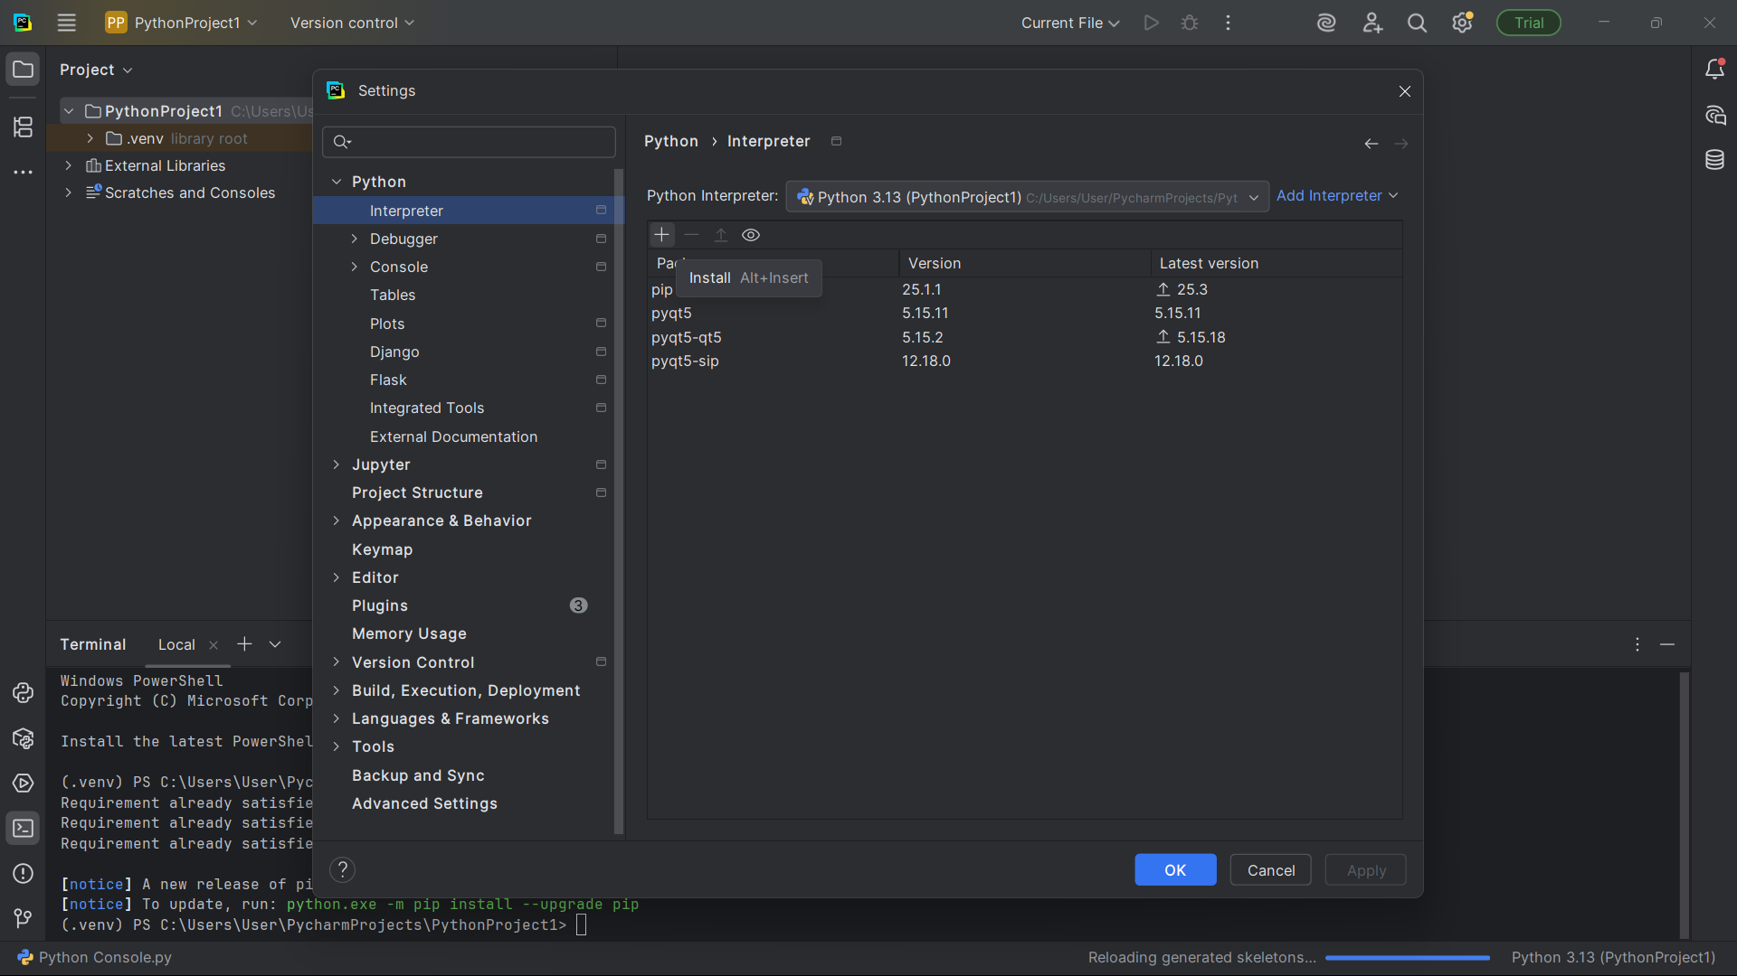
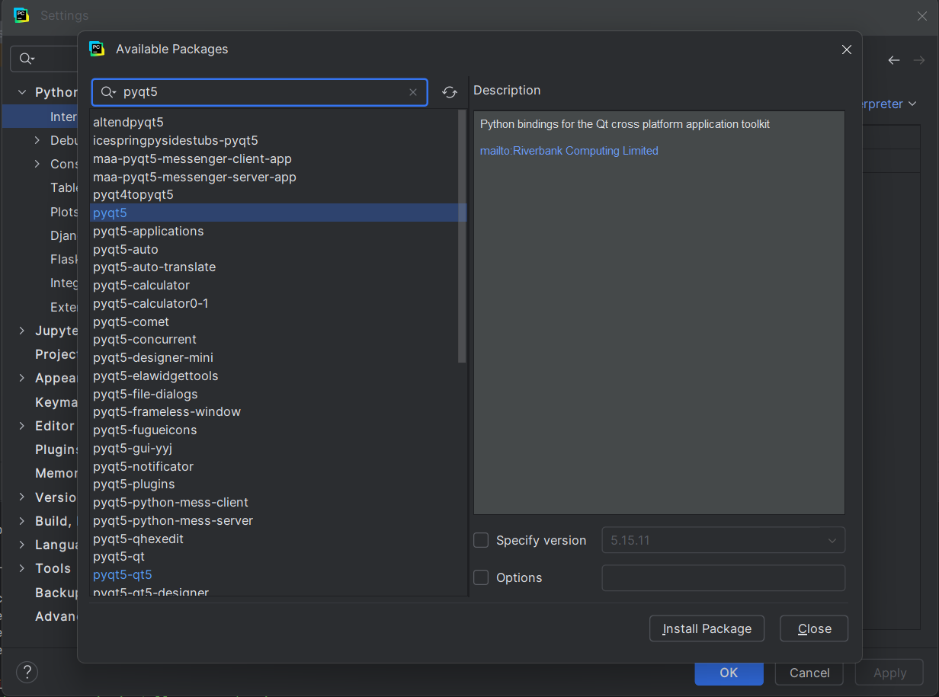
- PyQT5, PyQT5 stubs va PyQT5 sip o'rnatish (Install PyQT5, PyQT5 stubs, and PyQT5 sip):
  - PyQT5 ni o'rnatganingizdan so'ng, stubs va sip paketlarini o'rnating.
  - Buning uchun:
    - PyQT5 stubs paketini o'rnating.
    - PyQT5 sip paketini o'rnating.
    - Har ikkala paket o'rnatilganini tekshirib, xabar (message)ni o'qing.
- Agar IDE ishlatmasangiz (If you are not using IDE):
  - Agar IDE ishlatmaysiz bo'lsa, siz Python console orqali ham pip komandasini ishlatib PyQT5 ni o'rnatishingiz mumkin.
    - Konsolda pip install pyqt5 deb yozing.
    - Shuningdek, pyqt5 sip va pyqt5 stubs paketlarini ham o'rnatishingiz kerak:
      - pip install pyqt5/sip
      - pip install pyqt5/stubs

Natija (Conclusion):
- PyQT o'rnatilishi juda oson va oddiy, faqat PyCharm IDE yoki Python console orqali kerakli paketlarni o'rnating.
- PyQT5 versiyasi hozirda pyqt dasturlash uchun eng so'nggi versiya hisoblanadi va biz bu versiya bilan ishlaymiz.

Agar qo'shimcha savollar yoki tushunmovchiliklar bo'lsa, bemalol yozing!

In this session, we are going to create a first frame or a first application by using pyqt. So, in order to start with this, what are we going to do? We are going to create a new python file. So, in order to do that, we will just say a right click on the project name. So, here in my project name, that is first. I will just right click on this project. We will go to new and we will go to file.
Or you can directly select from here that is python file if you wish to. So, I am just clicking on python file. Let's say this is my first application. So, first app as a python file. So, this will be saved as .py. That's the extension for the python. And that is much required to work it.
Now see, if I just say, right for right now, if I just use a python command to just see how does my output looks like. I have just done this. And click on run. Run. The first app. So, I got the output, right? Now, what are we going to do here is, in order to start with your pyqt, the very first thing is, we have to import some libraries.
So, what we have to import at the base is, import sys. That is system. That's must for writing your pyqt application. Now, in this system, import sys, that is system, from. So, what we have to import, that is, pyqt5. That's your pyqt5. We will call qt widgets.
So, import sys from pyqt5.qt widgets That's first one is import sys for your function and all. And now, from pyqt5.qt widget, import q application and q widget. Now, this import sys is for defining, like suppose if I define main. That's the main function. And yes, that's it. So, whatever you write inside this function will be displayed to us. And here, I am just telling, if underscore, underscore name, underscore, underscore is equal, equal to underscore main. So, like you know, if your name is main, then execute main.
That's it. Now, what we have to do here. So, in this define main, what we have to write is that as app, that's the object, is equal to q application. So, we will be creating the object of q application. That's the app. And in this, we are using system. So, I will just mention sys dot argv, argument variable.
For this argument variable, we have import this sys and in order to also get your qt widgets, that's pyqt widgets, we have import pyqt widgets q application and q widget. Now, what we have to do. So, whenever we are creating application, we say a q application. Now, what we have to do is widget widget is equal to q widget. So, I am creating a widget right now. And now what I will just stay over here is widget dot now we will call all the methods. So, like I want to call first is resize.
That is I am giving a size to this. So, like let's say if I want the size of 250 and 200. If you will see the parameters over here inside. Ok. When I was typing this parameters, you can just see like 250 comma. Right now, it won't again display to me but yes I will show you dot resize 250 comma. Now, you can see it's showing you w int h int.
So, the first one is for your width and second one is for your height. Always remember that. So, that's why just to show you that which one is where, where we got the resize option. Then, now when I execute this code, I will definitely give gets like. Ok. I will just right now mention widget dot set window title. So, like window title I will give it as first pyqt application.
And we just need to do widget dot show. So, when we say show that means your widget is visible now. And in order to stop this program sys dot exit system dot exit is equal to app dot ex execution. That's to terminate your queue application. So, once your widget is shown, once you have set a close button that means your system dot application will be closed. So, it's just for the close button which we get a default close button. So, for this we write system exit option. Now, when I run this code, let's run this code to see the output.
You can see, I am getting a particular queue frame right and it's going me to the height and width. So, I will just change a bit more width. I will give it 2350 and this let's mention it as now 250. Save this and execute this. So, now you can see that this particular application pops in the center. Whenever I am executing this application, the application is actually popping up in the center. So, what if I want to pop it somewhere else? I can just mention one more option that is called widget dot move.
And now we will just give like for example I am telling 300. So, that's C. You can see A-axis A-Y. So, this is your X-axis then the second one will be your Y-axis. So, I am telling the X-axis and Y-axis is 300 and 300. Now, if I execute this code, you can see your X-axis to 300 and Y-axis to 300 and your application is placed somewhere at the left side of the corner. You can move it wherever you want to and you can display as you want to.
So, just to give a quick move what we have done, we have import a system for the system argument variables and to exit the system and we have also import pyqt widgets. That's Q-application and Q-widget. So, Q-widget is to create a particular frame and Q-application to start any pyqt application. Then we have define a main function. That's the function over here which we have defined. Where I am creating object of app is equal to Q-application and I give system argv that's argument variable. Then I give widget is equal to Q-widget. So, this Q-widget is creating a frame for us. Then I am giving the size of the frame.
I am positioning the frame giving a title and show. And this is to execute your main method. That's the main function. So, now in the next step we are going to see different widgets which is available in pyqt 5.

Mana siz so'ragan matningizni strukturalangan ko'rinishda tarjima qilaman:

Birinchi Frame Yaratish (Creating the First Frame) - PYQT bilan
Bugun biz PYQT yordamida birinchi frame yoki ilova yaratishni boshlaymiz. Buning uchun quyidagi qadamlarni bajarishimiz kerak:

1. Yangi Python Faylini Yaratish (Creating a New Python File)
- Loyihada yangi fayl yaratish:
  - Right-click qilib, loyiha nomi ustida bosing. Menimcha, bu yerda loyihamning nomi first.
  - New -> File ni tanlang.
  - Yoki siz Python file ni to'g'ridan-to'g'ri tanlashingiz mumkin.
- Fayl nomini first_app.py deb belgilab, .py kengaytmasi bilan saqlang. Bu Python faylini yaratish uchun zarur.

2. Python Kodini Yozish (Writing the Python Code)
- Kod yozishni boshlaymiz:
  - Python komandasi yordamida dastlabki chiqishni tekshirib ko'ramiz:
- print("First App")
  - Run tugmasini bosing va dastlabki chiqishni tekshiring. Bu "First App" ni ekranda ko'rsatadi.

3. PYQT Kutubxonalarini Import Qilish (Importing PYQT Libraries)
- Dastlabki qadam:
  - sys (sistema) kutubxonasini import qilamiz. Bu PYQT ilovalarini yaratishda zarur.
import sys
- PYQT kutubxonasini import qilish:
  - pyqt5 va qtwidgets kutubxonalarini import qilish kerak:
- from pyqt5.QtWidgets import QApplication, QWidget

4. Main Funksiyasini Yaratish (Creating the Main Function)
Main funksiyasini yaratib, barcha ishlarni shu yerda bajaramiz:
def main():
app = QApplication(sys.argv)
widget = QWidget()
widget.resize(250, 200) # Kenglik va balandlik
widget.setWindowTitle('First PYQT Application')
widget.show()
sys.exit(app.exec_()) # Dasturni tugatish
Main funksiyani ishga tushirish:
if __name__ == "__main__": kodi bilan main funksiyasini chaqiramiz:
if __name__ == "__main__":
main()

5. Frame Yaratish (Creating the Frame)
- QWidget yordamida frame yaratish:
  - QWidget - bu PYQT da asosiy grafik element (widget).
  - resize() metodi orqali frame o'lchamini o'zgartiramiz.
  - Window title ni setWindowTitle() metodi bilan beramiz.
widget.resize(250, 200)
widget.setWindowTitle("First PYQT Application")

6. Ilovani Ko'rsatish (Showing the Application)
- Widgetni ko'rsatish:
  - widget.show() metodi yordamida ilovani ekranda ko'rsatamiz.
  - Exit funksiyasini ishlatish uchun sys.exit() va app.exec_()ni chaqiramiz:
widget.show()
sys.exit(app.exec_())

7. Ilova O'lchamlarini O'zgartirish (Changing the Application Size)
- O'lchamni o'zgartirish: Ilovaning kengligini (width) va balandligini (height) quyidagi tarzda sozlaymiz:
widget.resize(250, 200)
- O'lchamlarni o'zgartirish: Kenglik va balandlikni ko'rsatuvchi parametrlari:
  - Kenglik: 250
  - Balandlik: 200

8. Ilovani Joylash (Positioning the Application)
- Ilovani ekranda joylashtirish:
  - widget.move(x, y) metodi yordamida ilovani ekranda joylashtiramiz. Bu yerda:
    - X-osi va Y-osi (X-axis, Y-axis) qiymatlari ko'rsatiladi:
widget.move(300, 300)
- Bu ilovani 300, 300 koordinatalarida joylashtiradi.

9. Quick Revision (Tez Takrorlash)
- Import qilingan kutubxonalar:
  - sys - tizim argumentlari va chiqish uchun.
  - pyqt5.QtWidgets - QApplication va QWidget ni import qilamiz.
- Main funksiyasi:
  - QApplication ob'ekti yaratildi, bu ilovani boshlash uchun zarur.
  - QWidget ob'ekti yaratildi, bu esa ilovaning asosiy oynasini tashkil qiladi.
  - Ilovaning o'lchami va nomi belgilandi, keyin widget.show() orqali ekranda ko'rsatildi.

10. Natijani Ko'rish (Running the Application)
- Ilovani ishga tushirganingizda, ekranda first pyqt application nomi bilan kichik bir oynali ilova ko'rinadi.
- Ilova o'lchami va joylashuvi siz belgilagan parametrlarga asoslanadi.

Xulosa (Conclusion)
- Biz PYQT yordamida birinchi ilovamizni yaratdik, uning o'lchami va joylashuvini sozladik.
- Endi keyingi qadamda PYQT 5da mavjud bo'lgan boshqa vidjetlar bilan tanishamiz.

